WashWise Application Workflow
Customer Mobile App and Admin Staff System
Purpose. This workflow defines how customers, administrators, and staff use WashWise. Customers create their own mobile-app accounts. The administrator creates every staff account using an email address and temporary password. Staff cannot register themselves.

WashWise Entity Relationship Diagram
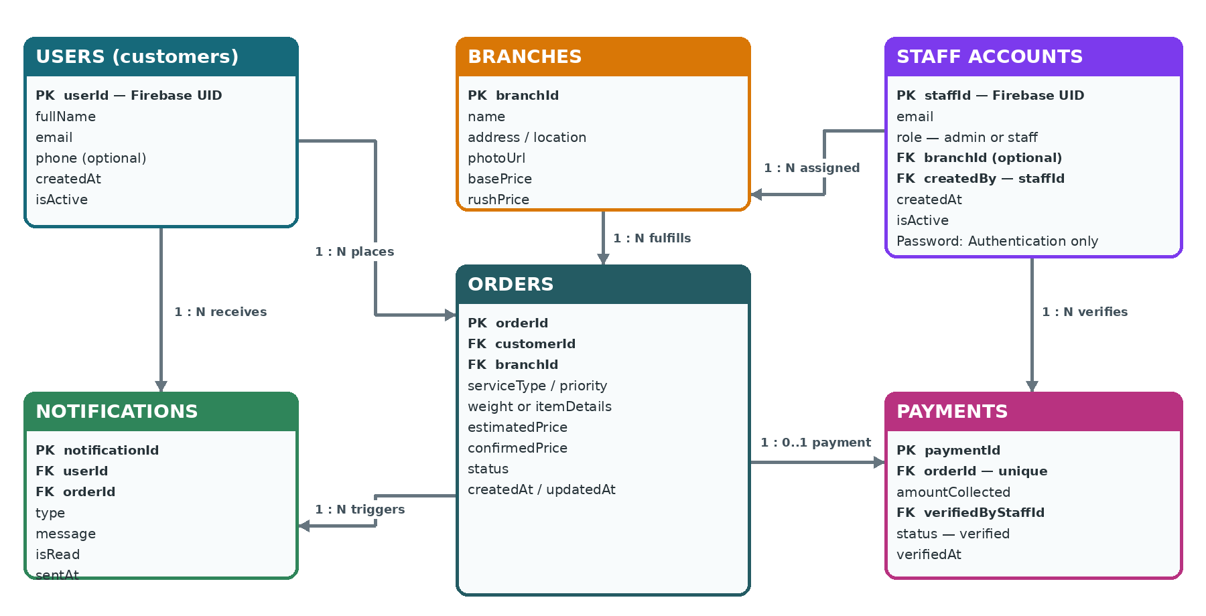
Figure 1 WashWise Firestore Entity Relationship Diagram

1 Customer Mobile App Workflow
Sign Up or Log In -> Select Branch -> Place Order -> Drop Off Laundry -> Track Status -> Receive Ready Alert -> Pay and Pick Up -> History
Stage | Customer action | System result
Account | Sign up or log in using the supported customer authentication method. | Creates or reads the customer account in users.
Branch selection | Browse branches and choose a laundry branch. | Reads branch information and current prices from branches.
Order placement | Choose service and priority, enter laundry details, and confirm the estimate. | Creates an order with status pending_dropoff and an estimated price.
Drop off | Bring the laundry to the selected branch. | Staff verifies the actual weight or items and confirms the final price.
Tracking | View the order progress in the mobile app. | Status changes through received, washing, drying, and ready.
Ready notification | Receive and open the ready-for-pickup alert. | Creates a notification record and sends the push alert.
Payment and pickup | Pay in person and collect the laundry. | Staff records payment and changes the order to completed.
History | Review completed orders. | Shows only the customer's completed order records.

2 Administrator Workflow
Admin Login -> Dashboard -> Create Staff Account -> Manage Branches and Prices -> Monitor Orders
Admin function | Required action | Stored result
Create staff account | Enter only the staff email and a temporary password. | A protected backend creates the authentication account and a staffAccounts record.
Automatic staff fields | No manual input is required. | The system sets role=staff, createdBy, createdAt, and isActive=true.
Manage access | Deactivate or reactivate a staff account. | The account remains recorded for accountability while login access is controlled.
Manage branches | Add or update branch information and pricing. | Updates the branches collection.
Monitor operations | View orders, payments, and staff activity. | Reads operational records without changing customer ownership.

Security rule. The staff password is stored only by Firebase Authentication and is never written to Firestore. Staff account creation must use a protected server function that verifies the requester is an administrator.

3 Staff Workflow
Staff Login -> View Branch Orders -> Verify Laundry and Price -> Update Processing Status -> Mark Ready -> Record Payment -> Complete Order
Stage | Staff action | System result
Login | Enter the email and password created by the administrator. | Checks authentication and confirms an active staffAccounts record.
Order queue | Open orders assigned to the working branch. | Shows pending drop-off, active, ready, and recently completed orders.
Verification | Enter actual weight or item details and confirm the final price. | Updates the order and changes its status to received.
Processing | Change status as work progresses. | Updates received -> washing -> drying -> ready.
Ready | Mark the finished order ready. | Creates the ready notification before the customer arrives.
Payment | Enter the amount collected when the customer picks up the laundry. | Creates a verified payment linked to the order and staff account.
Completion | Confirm that payment and pickup are complete. | Changes status to completed and moves the order into customer history.

4 Order Status Rules
Status | Meaning | Set by
pending_dropoff | Customer submitted the order but has not dropped off the laundry. | System
received | Staff accepted and verified the laundry. | Staff
washing | Laundry is being washed. | Staff
drying | Laundry is being dried or prepared. | Staff
ready | Laundry is ready; the customer is notified. | Staff
completed | Payment was recorded and the laundry was collected. | Staff
cancelled | The order was cancelled with an optional reason. | Authorized user

5 Data Collections
Collection | Purpose | Primary owner or writer
users | Customer profiles for people using the mobile app. | Customer and system
staffAccounts | Administrator and staff identity, role, status, and audit fields. | Administrator through protected backend
branches | Branch details, location, and pricing. | Administrator
orders | Customer order, confirmed price, assigned branch, and lifecycle status. | Customer creates; staff updates
payments | In-person payment linked to an order and verifying staff member. | Staff
notifications | Customer alerts linked to an order. | Trusted system process

6 Access Rules Summary
Role | Can do | Cannot do
Customer | Manage own profile; create and view own orders; read own notifications. | View other customers, create staff accounts, or change payment records.
Staff | View operational orders; confirm price; update status; record payments. | Create staff accounts, change roles, or manage administrator access.
Admin | Create and deactivate staff accounts; manage branches and pricing; monitor all records. | Read or store user passwords in Firestore.

7 Important Implementation Notes
• Customer and staff/admin login credentials may use the same Firebase Authentication project, but their profile records are stored separately in users and staffAccounts.
• The staff creation screen asks only for email and temporary password. The system adds role, createdBy, createdAt, and isActive automatically.
• A ready order must be notified before payment and pickup. Payment changes the order from ready to completed.

